Draktsho Vocational Training Centre for Special Children and Youth
Annual Report 2019

Table of Contents Page

- Foreword.......................................................................................................... .3
- Draktsho Introduction ................................................................................... 4
- World Down Syndrome Day ......................................................................5
- Celebrating the Birth Anniversary of H.E. Khamtrul Rinpoche..................6
- Draktsho's Special Olympians..........................................................................7
- Waste Management Initiative .........................................................................8
- World Autism Day .........................................................................................9
- Teachers Day Celebration................................................................................10
- Draktsho Dharma Day .............................................................................. 11
- Summer Youth Art Camp.............................................................. ................12
- Ability Show ........................................................................ 13
- Foundation Day ..............................................................................................14
- Inauguration of New Infrastructures ..........................................................15-16
- Football for Climate Action ..........................................................................17
- World Childrens Day......................................................................................17-18
- International Day for Persons with Disabilities...........................................19-20
- Program and Activities .................................................................................21-30

Foreword
Draktsho has sprung from a small group of kids making beautiful paper flowers; ripping papers to make objects out of them. I can remember the smile on their faces as they played with toys and balloons. It is the smile on their faces that make us want to bring more joy and happiness in their lives.
Over the years we have seen other related organizations like Ability Society Bhutan and Disabled Persons Association of Bhutan come up and flourish well. It is a wonderful feeling to know that Draktsho has shown the way for the others to follow so that the children and people living with disabilities can enable every opportunity to participate in the development of the people and the country. Most importantly they can be contributing members of the societies.
Draktsho is trying its best to provide a wide range of vocational skills for every different child, however, these development poses big challenges financially. It is very important to be financially secured and the question is where will we get the money when there is not enough money to run the basic activities!
Fortunately, we can count on our partners, stakeholders and local supporters on the support of our activities and the children in this difficult task. We know how difficult it is run an organization that has no fixed foreign donors or a Trust fund to reinforce its financial need. But urged on, Draktsho will continue the important role of the front runner for the sake of children and people with disabilities.
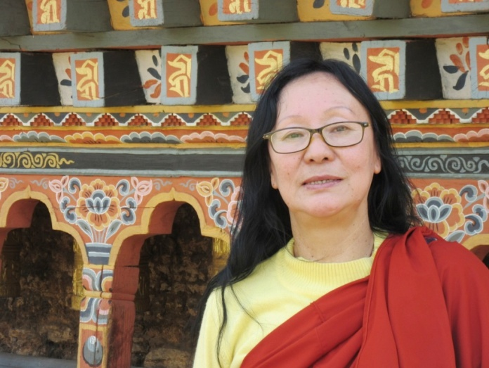
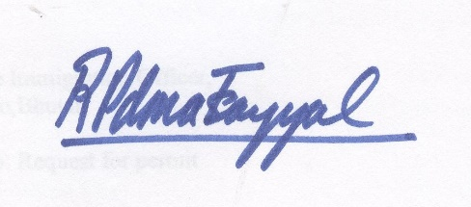
Rigzin Padma Tsogyal
Founder & Director
Drak
Draktsho
Drak-Tsho is currently the only parent initiated vocational training program in Bhutan that specifically targets children and young people who have a disability. Drak-Tsho is the first of its kind in the country; it’s a service- oriented and non-profit making centre which aspires to enhance the living standard of children and youth with disability through empowerment by training, education and eventual integration with the mainstream population. Its main focus is to equip the trainees with vocational training skills to enhance their opportunities for gainful employment. It also aims to build their self-esteem and self-reliance, thereby making them more independent, confident and contributing members of the society. The Centres (Thimphu & Kanlung, Tashigang) encompasses opportunities that allow them to grow in their aptitude, determination, goals and dreams. One of the greatest challenges for the centre is to erase the deeply embedded stigma.
The management staff of the Drak-Tsho promotes the recommendations recorded in the 2007 ‘Master Plan’. There have been a lot of activities at the Centre like the development of written curricula for life skills which would provide not only identifiable guidelines for the staff and students, but also a means of providing the basis for evaluation of the program and the progress of students. Lot of awareness raising programs have also been organized.
The first branch of Drak-Tsho, based in Kanglung, Tashigang caters the same kind of services that are taught at Thimphu Centre. Plans for including more traditional based training and conventional based training are being developed to engage every student.

Our main objectives are:
- To provide training in life skills including basic literacy and numeracy to persons with special needs for enabling them to cope with their daily life needs in present and future.

- To equip trainees with special needs with vocational and work skills as preparation for sheltered, open or self-employment.

- To facilitate the trainees with special needs secure work with dignity.

- To initiate dialogue, build collaborations and networks with different stakeholders (government, industry, institutions etc) for actively promoting equal opportunities for people with special needs.

- To organize parent support and community outreach program for raising awareness and generating support for inclusion of persons with special needs.

- To conduct training, research and documentation for building human resources, supporting innovative actions and generating resource material and data for supporting quality services and advocacy.

While providing services and special education to children and youth with disabilities, Draktsho assures that all the International Days for people with Disabilities are celebrated. The first Day of celebration starts with the World Down Syndrome Day.

World Down Syndrome Day
Down Syndrome is a genetic occurrence caused by extra material in chromosome 21 that results in intellectual disability. It is not yet known why this occurs. The estimated incidence of Down Syndrome is between 1 in 1,000 to 1 in 1,100 live births worldwide. Each year approximately 3,000 to 5,000 children are born with this chromosome disorder and it is believed there are about 250,000 families in the United States of America who are affected by Down Syndrome. The General Assembly decided, with effect from 2012, to observe World Down Syndrome Day on 21st March each year, and invites all Member States, relevant organizations of the United Nations system and other international organizations, as well as civil society, including non-governmental organizations and the private sector, to observe World Down Syndrome Day in an appropriate manner, in order to raise public awareness of Down syndrome.
The World Down Syndrome Day was celebrated at both the centres of Draktsho, Thimphu and Tashigang. On 21st March, Draktsho East Centre organized an awareness walk from Sherubtse College till Draktsho East Centre following the theme: “leave no one behind.” The program started around 9 am at Sherubtse College’s main gate where Dasho Thrizin of Trashigang Dzongkhag kindly graced the event. The awareness’ walk was a success that concluded with cultural activities, games and lunch at the centre.
On the other end students of Draktsho Thimphu visited Kuensel Phodrang park where a talent show was organized. The students performed various talent's such as singing and dancing. prizes and gifts were distributed to all the students ensuring that no child felt left behind, in keeping with what was the theme for the year.

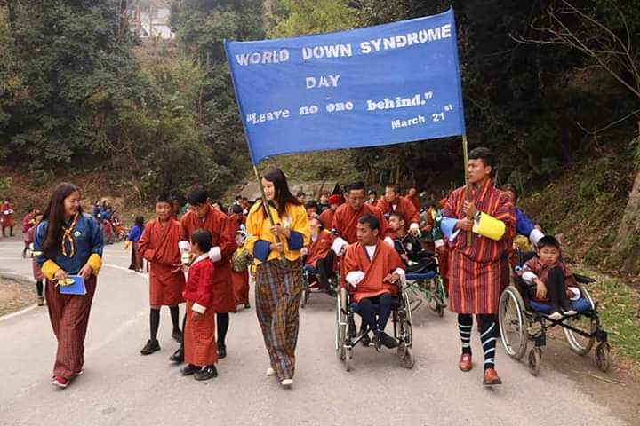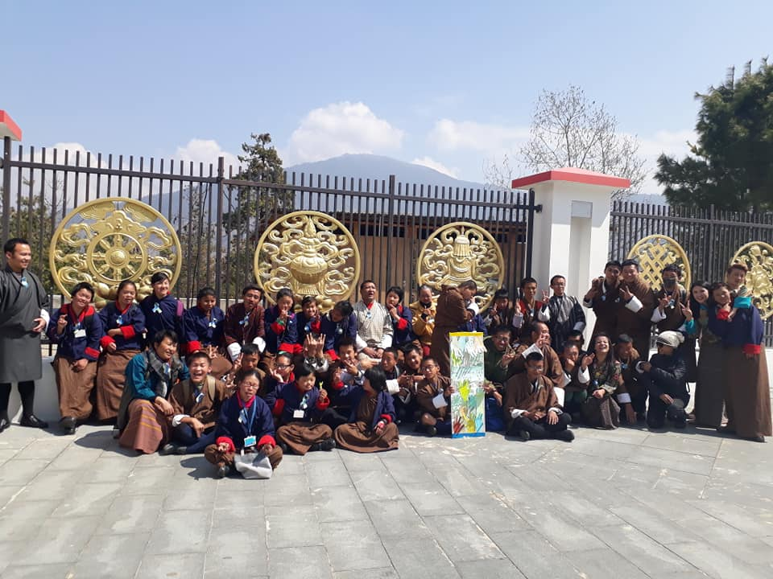

Celebrating the Birth Anniversary of His Eminence Khamtrul Rinpoche

On 29th March, Draktsho family had the opportunity to offer their heartfelt gratitude and prayers for H.E. Khamtrul Rinpoche on his birthday. Draktsho is blessed to be remembered by Rinpoche and remains grateful for all the support Rinpoche has rendered towards Draktsho. That day Draktsho received cake and snacks from Rinpoche.

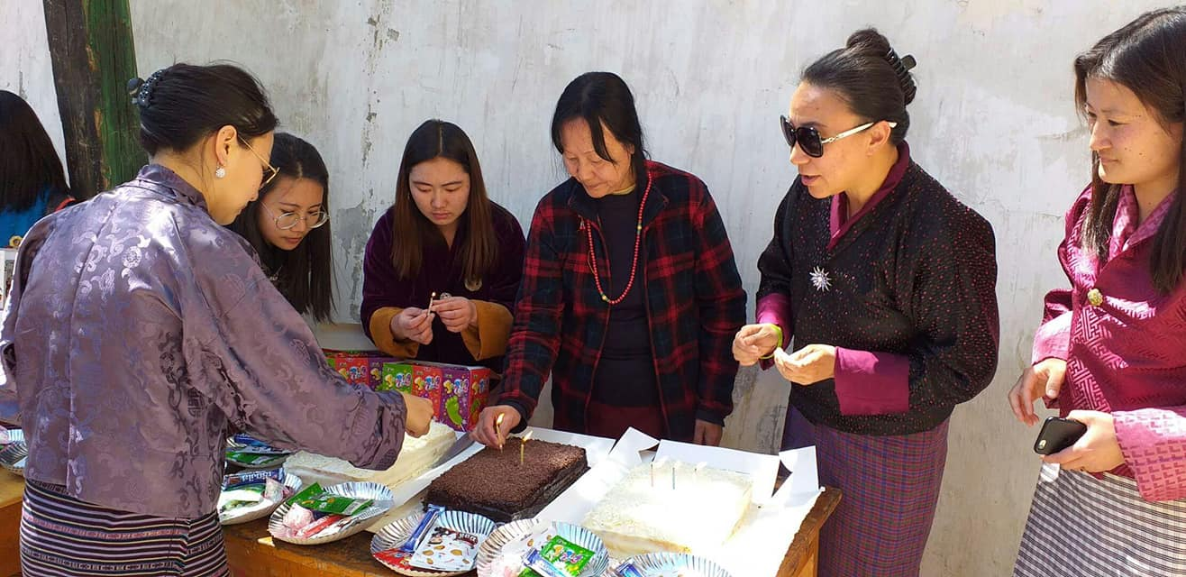

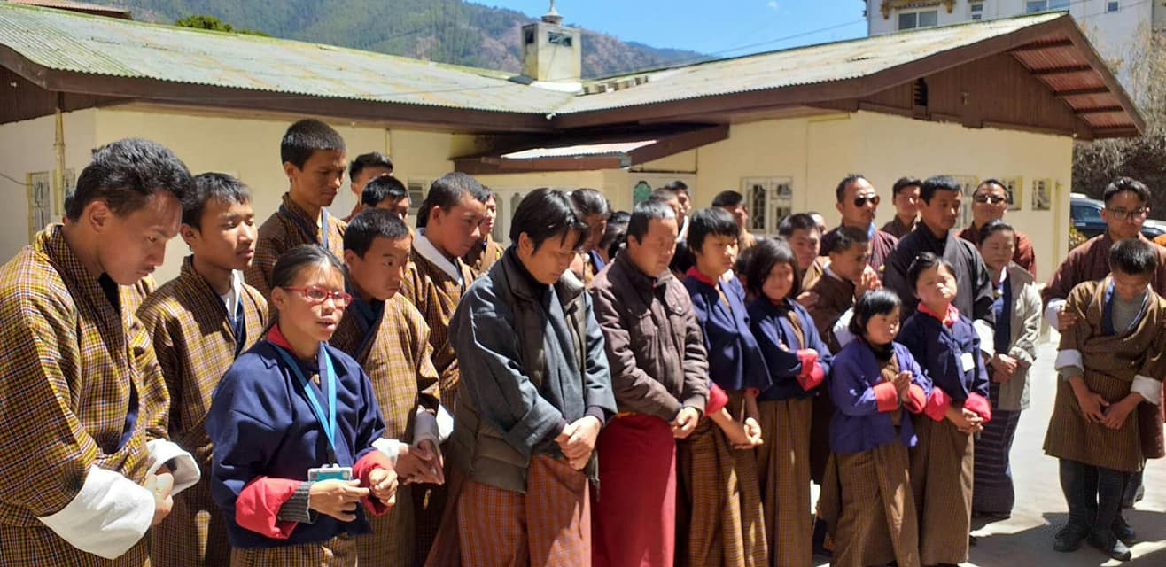

Draktsho’s Special Olympians

A delegation consisting of 7 people( 4 athletes,2 coaches and 1 Head of Delegation) participated at the Special Olympics held in Abu Dhabi in United Arab Emirates from 14th-21st March,2019. The four athletes from Draktsho were selected on performance basis through a national competition that was held in Thimphu. It is not the first time that athletes from Draktsho had participated at the Special Olympics but the third time. The first games was held in Athens, Greece in 2011,the second in Los Angeles in 2015 and the third in Abu Dhabi. It is also not the first time that our athletes were victorious but for the third time.
On 23rd March, our athletes returned victorious with 2 gold, 1 silver, and 1 bronze medal after competing in track and field events such as 100 mts race,200 mts race and shot put. It was such an honour to receive our hero's home especially for Ms.Leki Lhaden as she brought home a gold medal in the women's 100 mtr race. Her parents were so happy and never felt so proud of their daughter.
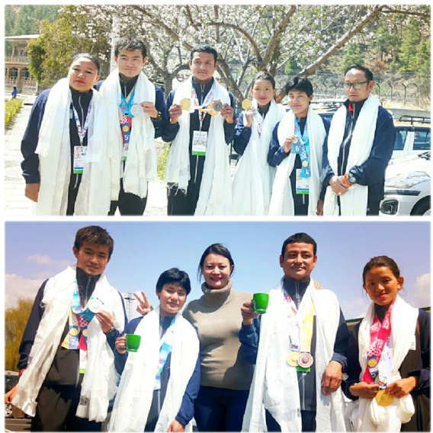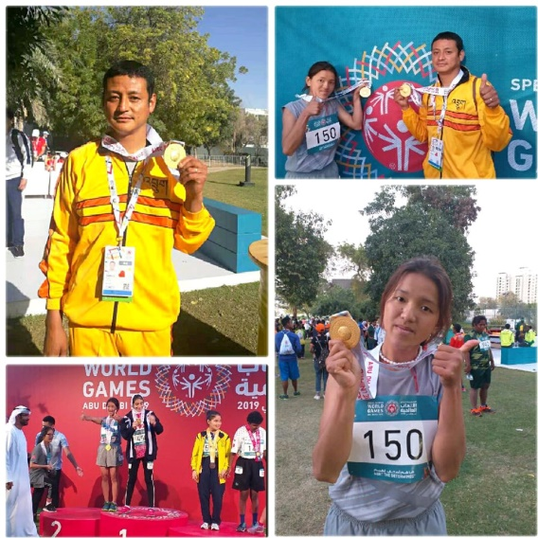
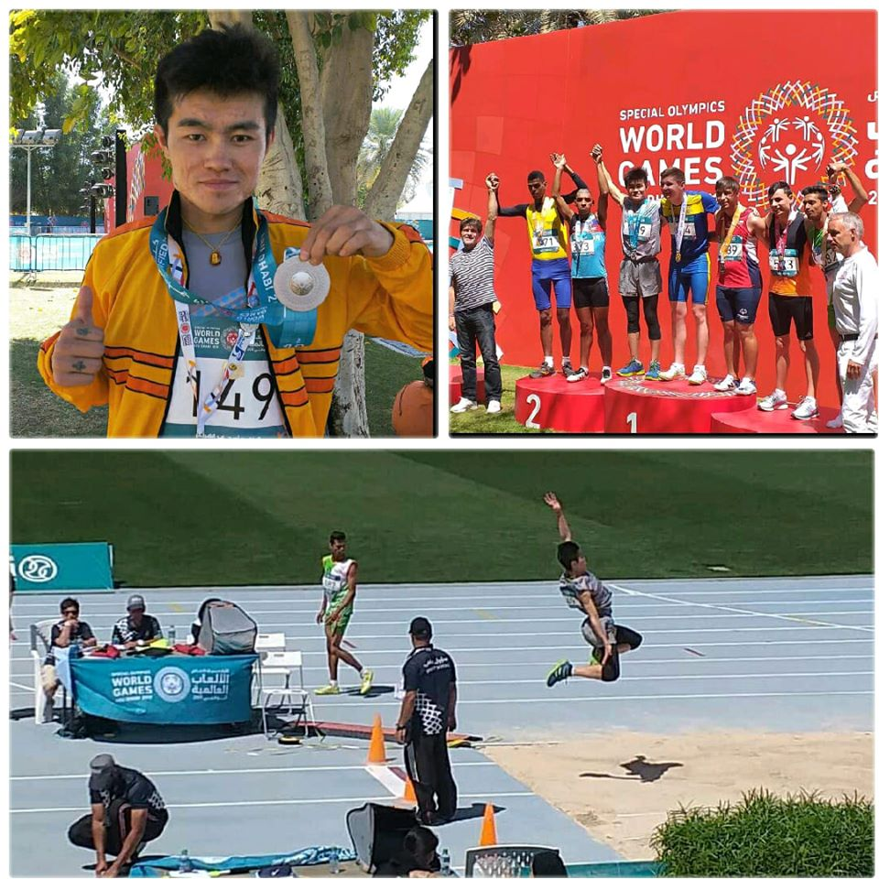
Waste Management Initiative
Draktsho East Centre in collaboration with Sherubtse College initiated a Cleaning Campaign on 31st March. The students and teachers of Draktsho and Sherubtse College came together to make Shinangkhar Community in Kanglung a healthier and cleaner place. This awareness campaign not only created awareness about "clean environment" but it also created a sense of responsibility amongst the people the importance and benefits of living in a clean community.
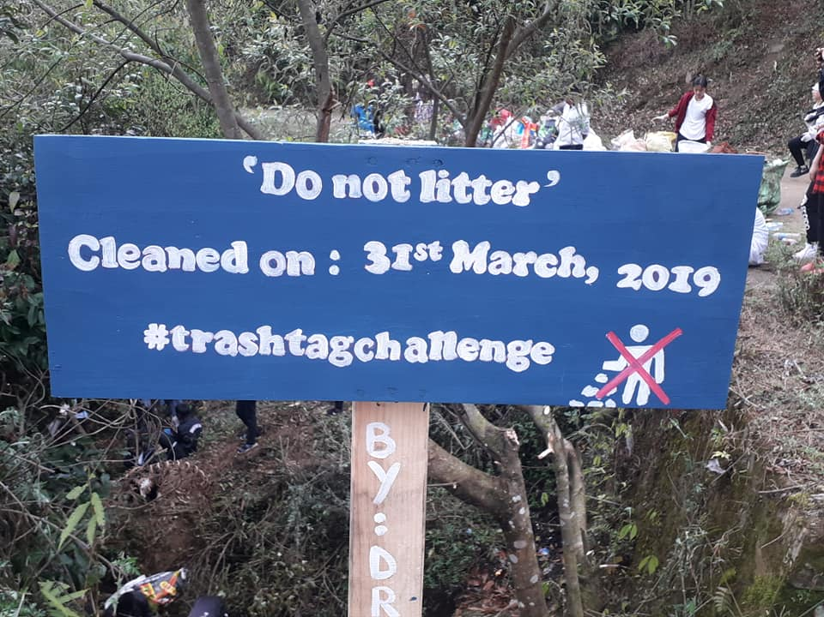

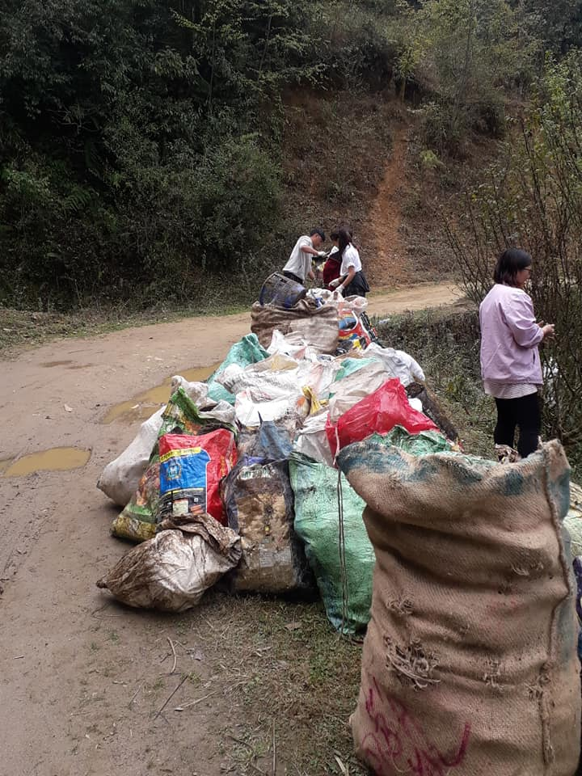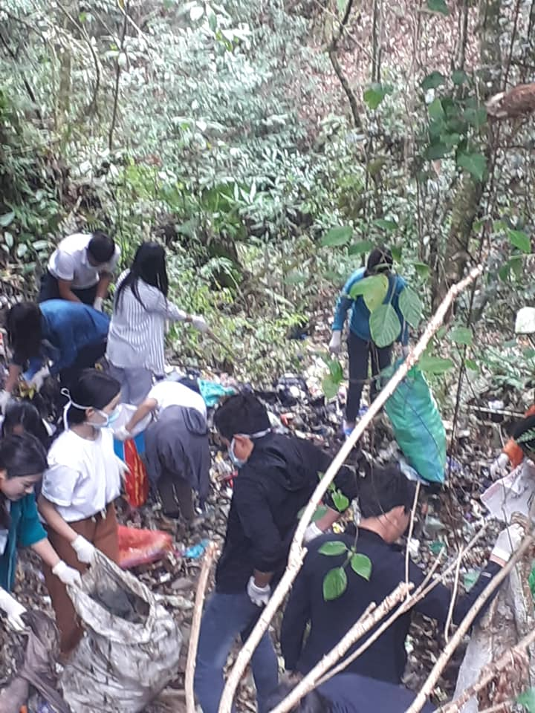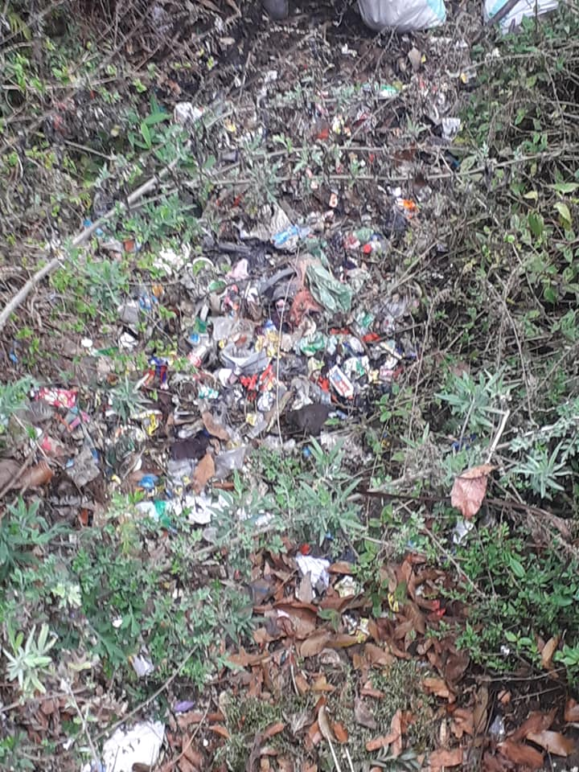

World Autism Awareness Day
World Autism Awareness Day is an internationally recognized day on 2nd April every year, encouraging Member States of the United Nations to take measures to raise awareness about people with autism throughout the world. It was designated by the United Nations General Assembly resolution "62/139. World Autism Awareness Day", passed in council on 1 November 2007, and adopted on 18 December 2007. It was proposed by the United Nations representative from Qatar, Her Highness Sheikha Mozah Bint Nasser Al-Missned, Consort of His Highness Sheikh Hamad Bin Khalifa Al-Thani, the Emir of the State of Qatar, and supported by all member states.
This resolution was passed and adopted without a vote in the UN General Assembly, mainly as a supplement to previous UN initiatives to improve human rights. World Autism Day is one of only four official health-specific UN Days. The day itself brings individual autism organizations together all around the world to aid in things like research, diagnoses, treatment, and overall acceptance for those affected by this developmental disorder.
The Autism Day is one of Draktsho's annual event where students, teachers, parents and volunteers aim to raise awareness on Autism, accepting people with Autism and celebrate their happiness. Students at both the centres marked the day by performing cultural activities, playing fun games and enjoying to their fullest. It was a day to be remembered.
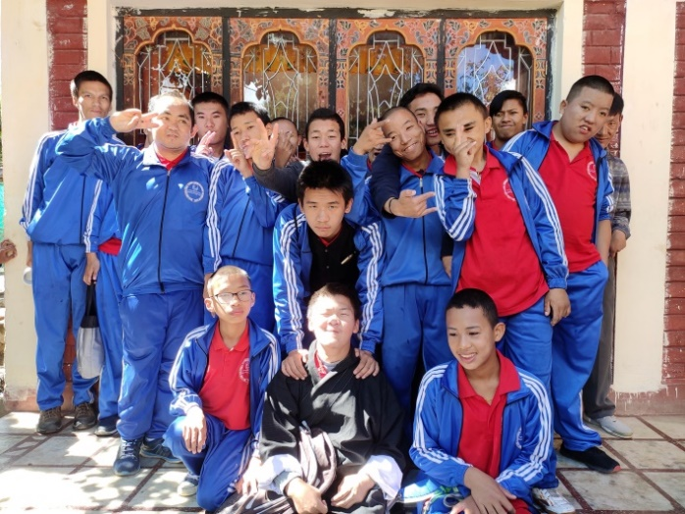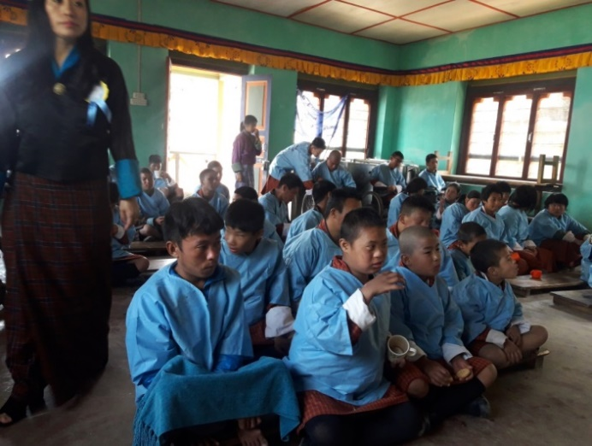

Teachers Day Celebration
On 2^{n} May, Draktsho celebrated Teachers’ Day to thank all the teachers in and around the country for their selfless contribution towards bettering the lives of country’s future generation. This day also coincides with the birth anniversary of late His Majesty the Third Druk Gyalpo King Jigme Dorji Wangchuck (considered the Father of Modern Bhutan).
At Draktsho Thimphu, the teachers gathered for a lunch, cultural performances, and games organized by the students. It was a day of great importance as students thanked and shared deep appreciation towards all teachers for the energy they put into educating the students every day. On the other hand, it was an emotional day for the teachers seeing their students recognize and acknowledge the head and heart teachers put into their work every year. A similar celebration was organized at Draktsho East. The event started from 9 in the morning and concluded with lunch all organized by the students independently.

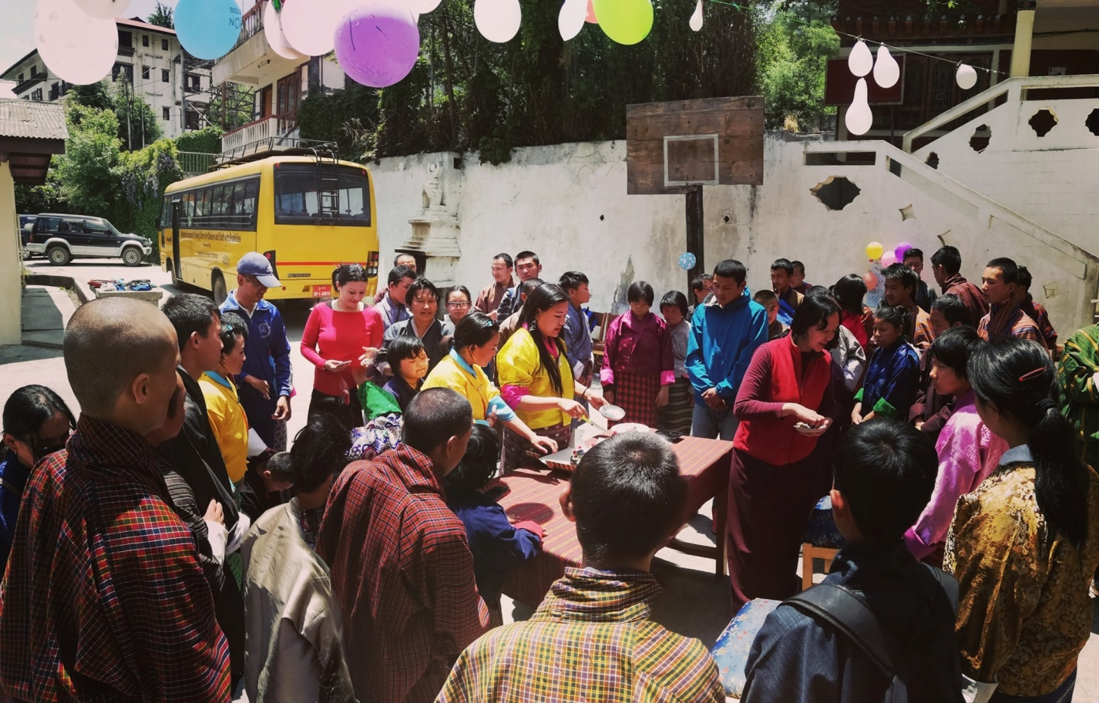

Draktsho Dharma Day
Saga Dawa is the fourth month of Lunar Calendar and it is the holiest month for all Tibetan Buddhists or Himalayan Buddhists. Saga Dawa is one such duezang or powerful auspicious time because the external and internal conditions are right, the historical Buddha, according to the Bhutanese calendar, is said to have experienced the five major events in his life on the full moon day of Saga Dawa. The Buddha is believed to have been conceived, born, to have defeated evil forces, attained enlightenment and passed away into Mahaparinirvana on this day.
Draktsho initiated a mass feeding program in 2016 to mark this auspicious month every year. Student, teachers, parents and volunteers gathered bringing their own food items such as mixed dough prepared in milk, sugar, bread, biscuits, cooked rice and other food items that can be consumed directly. The group divided into smaller groups and started their mass feeding program starting from the dogs within the compound. The groups dispersed in different directions feeding the dogs, ants, fishes, cats and cows. This not only excites all but it helps gain merit, purify one's mind, bring peace, joy and satisfaction to all involved through this good deed.

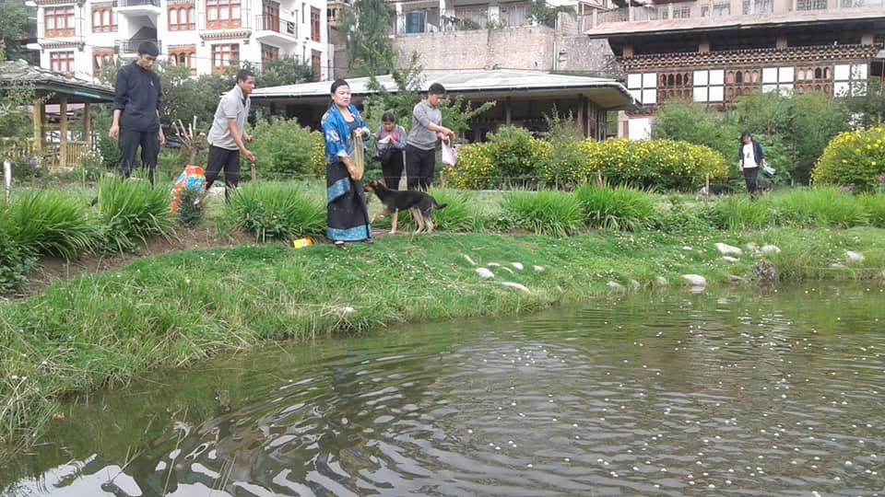
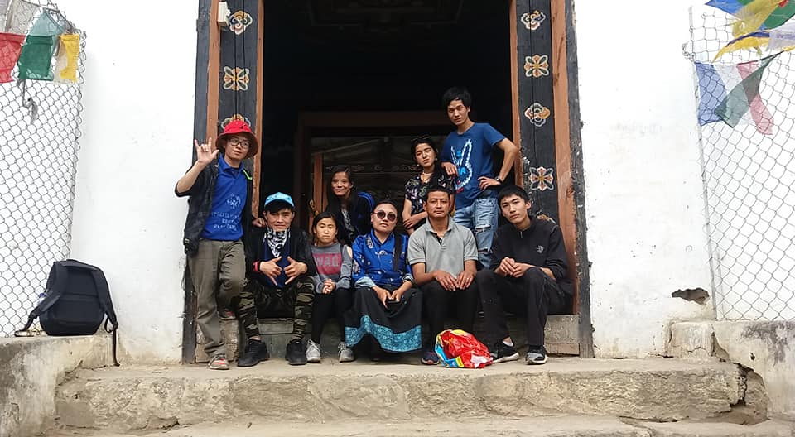
Summer Youth Art Cam
Whilst the students of Thimphu were enjoying their summer vacation with their families outside the campus, students at Draktsho East Centre were meaningfully engaged at the Summer Youth Art Camp organized by VAST Yangtse. The Art Camp began on 13th July and concluded on 23rd July where the students trained in basics of contemporary art, water colour painting, traditional art, and finally photography. This event was supported by the Royal Office of Media and people from Switzerland. The 10 days Summer Youth Art Camp turned to be very exciting for the students as it gave them the opportunity to learn various art and photography skills from professionals.
Mr.Markus Wild not only taught photography lessons during the camp but also donated a professional Canon Camera to Draktsho East Centre.
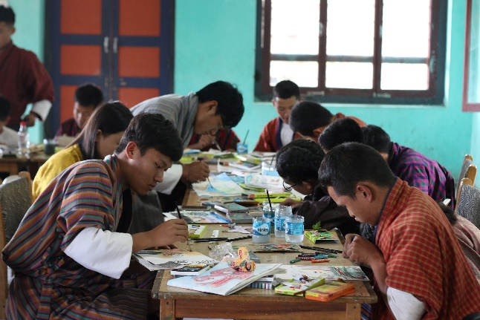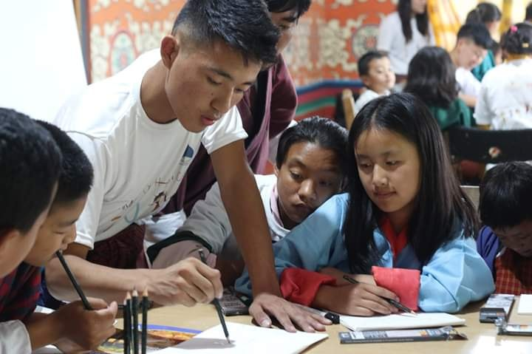
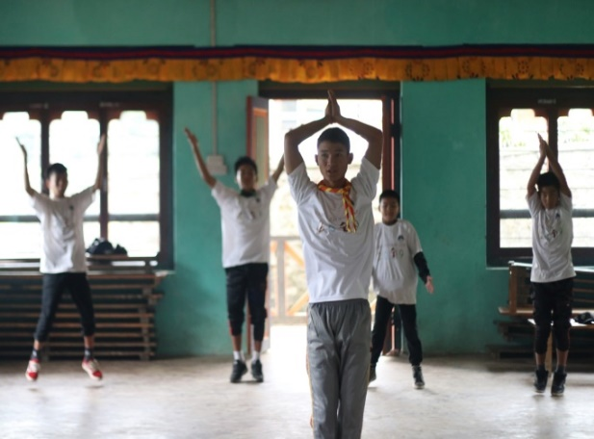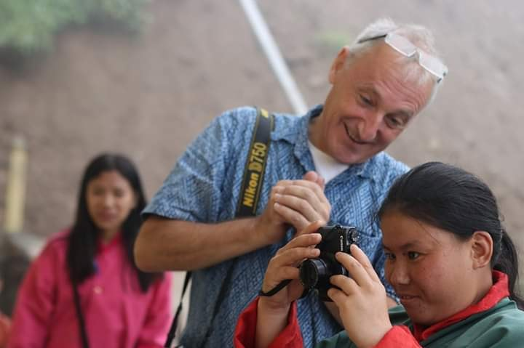
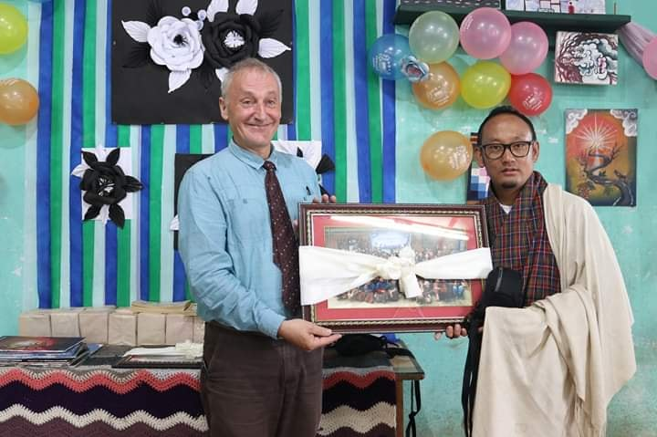
Ability Show
The 2 days Annual Ability Show was organized by Draktsho East Centre at Jampeling Central School and Sherubtse College on 31st August and 1st September respectively.The students showcased various cultural performances such as singing, dancing and stage acts to raise awareness on what persons with disabilities could do to reduce the societal stigma" persons with disabilities cannot do anything". The show was a success as the audience applauded with appreciation and acceptance.
The show was organized in collaboration with Social Service Unit(Sherubtse), Bhutan Kidney Foundation (Sherubtse) and FINA(Sherubtse). The show would not have been possible with the support from these groups as well as Jampeling School and Sherubtse College.

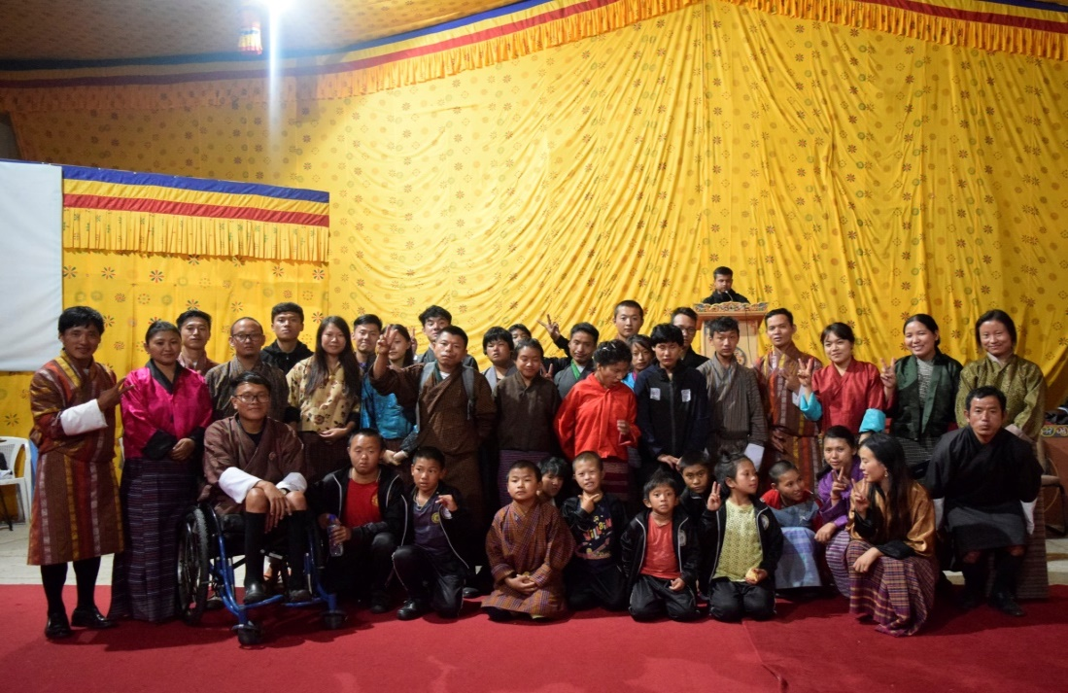
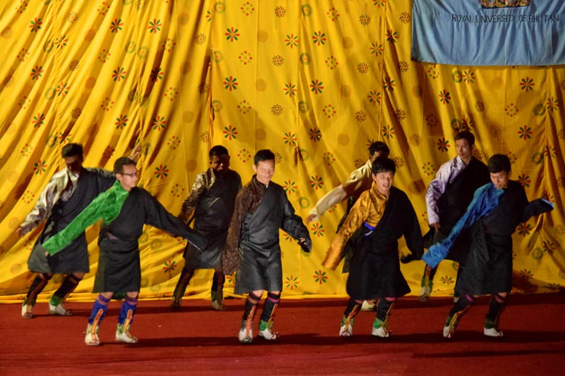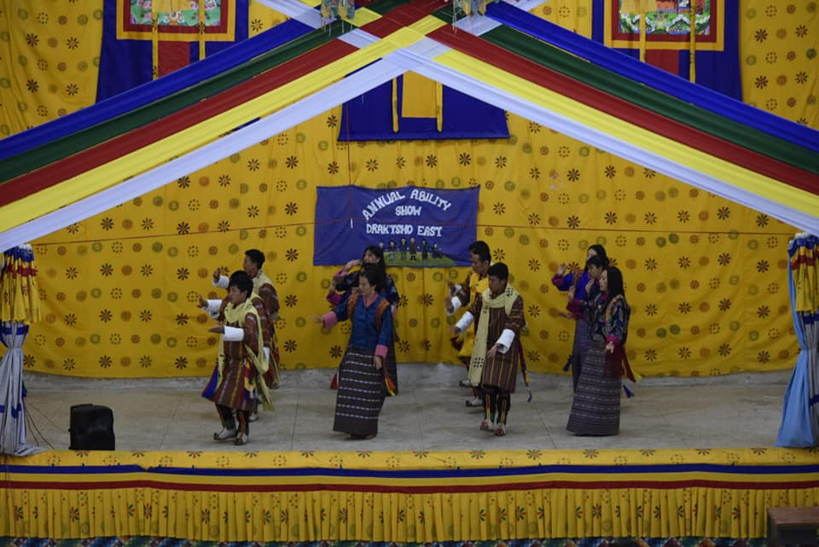
Foundation Day
2nd October is one of the most memorable annual event that everyone looks forward to as on this day in 2001 Draktsho was born. To mark this special occasion students, parents, teachers and volunteers gathered at Draktsho Centre for lunch with cultural program treats from the students.

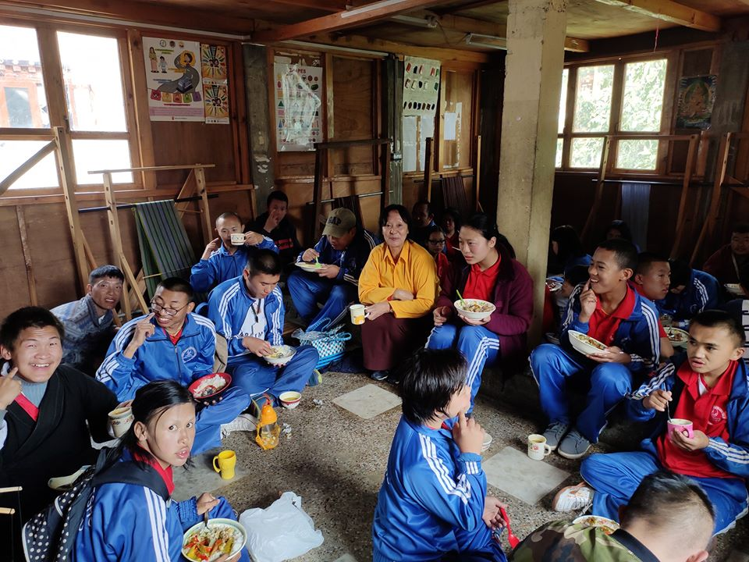
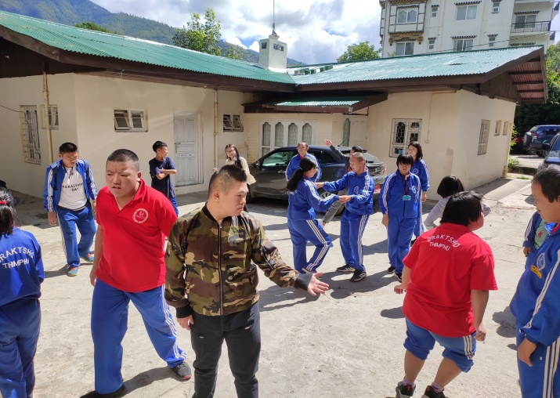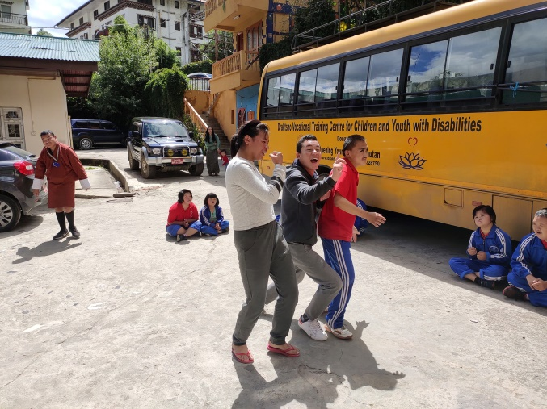

Inauguration of New Infrastructures
On the 9th of November 2019, Save the Children Bhutan with support from Save the Children U.S through donations from Mr. William Mark Haber and his wife Ms. Heike Margarethe Sommers inaugurated new infrastructures at the Draktsho East Center.
The delegation to the east was led by the SC Board Chairman Mr. Bradley Chapman Irwin who was accompanied by his wife Ms. Catherine Kane Irwin, the donors Mr. Haber and Mrs. Sommers, also in the delegation was Mr. Charles Frederick Mac Cormack, former President of SC US and other board members Ms. Katherine Jordan Oppenheimer, Ms. Margaret Ann Mc Getrick and the Senior Director of Individual Philanthropy Ms. Jessica Shoshone SC U.S. The SC Bhutan team led by the National Director were also part of the celebration along with local community, the founding member of Draktsho, the Executive Director of Draktsho. Representatives from locals NGOs such as ‘Opening Hearts to Bhutan,’ ‘Nazhoen Lamtoen’ and ‘Ability Bhutan Society,’ college students from Kanglung and the Draktsho students.
The infrastructures supported include a classroom building with four classrooms and an auditorium/ Multi-purpose hall for Draktsho East in Trashigang District.
Draktsho East is a vocational training centre focused on providing functional education and vocational skills to children with mild-moderate disabilities. They currently have 67 students with varying degrees of disabilities who avail the services of the centre and reside on campus where hostel services are provided.
The new infrastructure will be used as classrooms and vocational training labs will enable the center to greatly expand its current enrollment and minimize the congestion that the school faces.

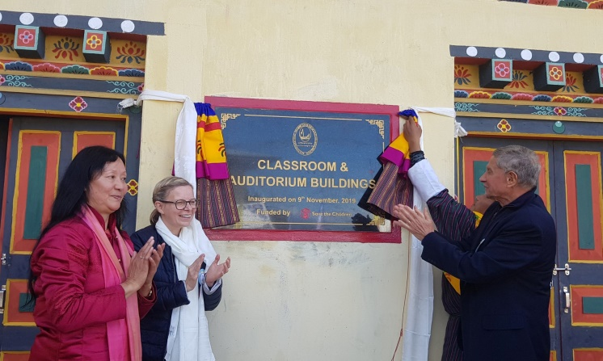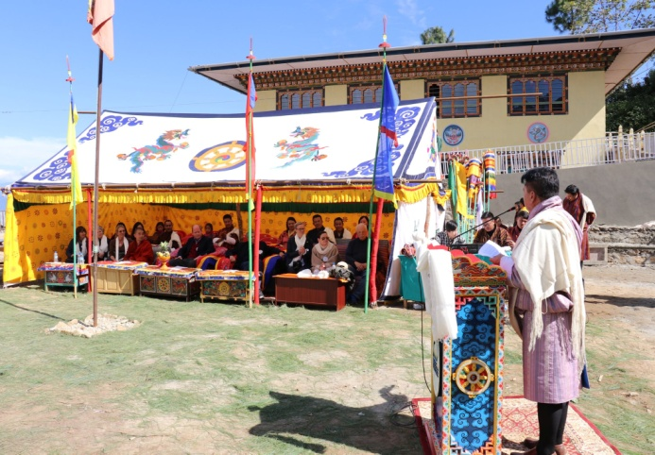
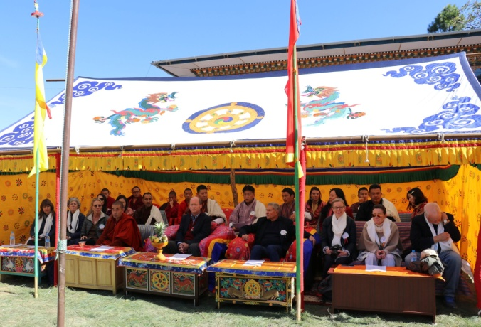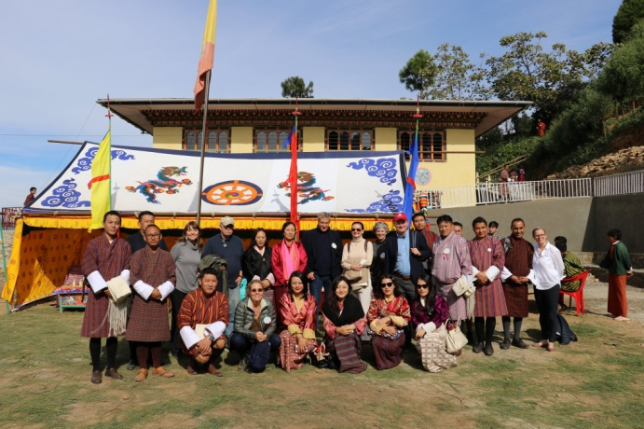
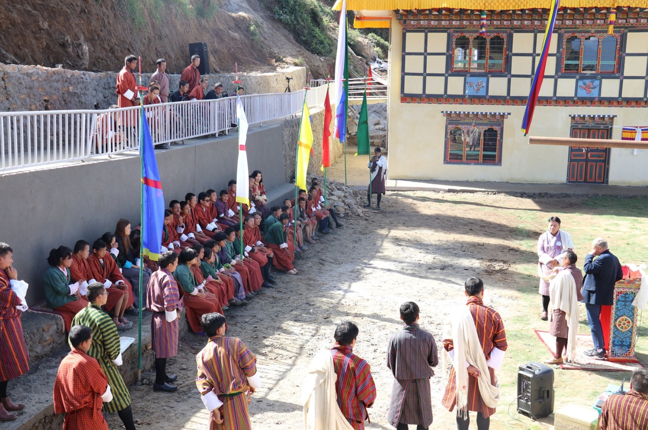

Football for Climate Action
On the 12th November, 46 students from Draktsho Thimphu participated in "Football for climate action" event organized by Bhutan Football Federation. It was a very fruitful day where students took part in various sporting activities. The sporting event helped our students work on improving their gross motor and fine motor skills. Some activities required students to hit a target with a ball, while some required them to catch a ball whilst in the air. Our students were also trained in hand-eye coordination.
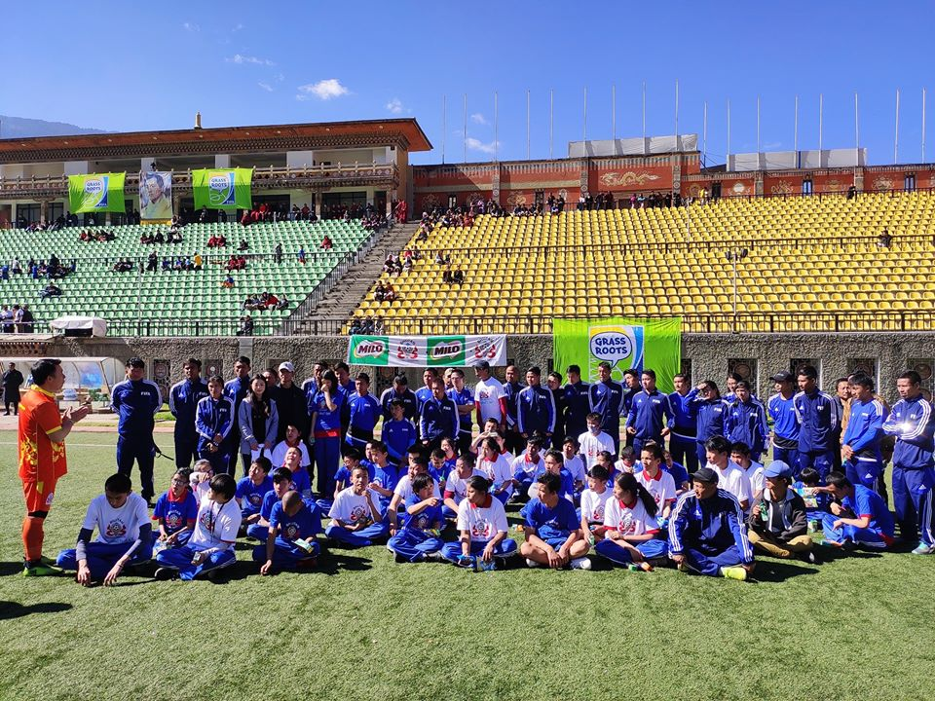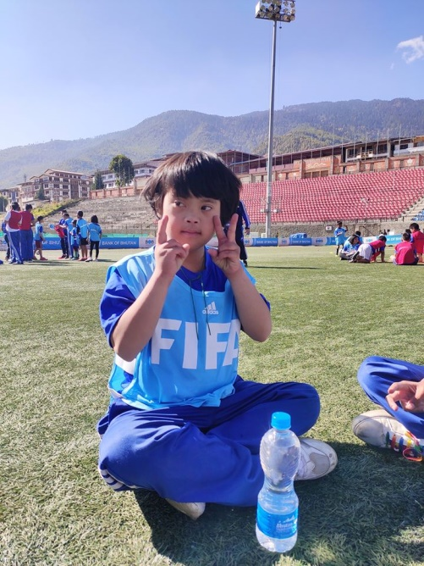
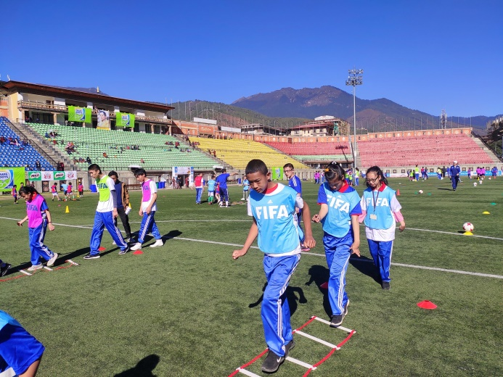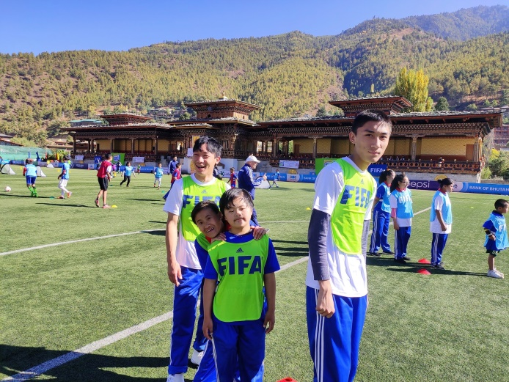

World Children’s Day
November 20th is celebrated as World Children’s Day by the United Nations annually in honor of children. Every child needs care and protection. Realizing the importance of the day Draktsho East observed the day by going for a picnic. It has always been one of Draktsho’s primary goals to raise greater awareness in the community regarding the need for better security measures for persons with disabilities in the society that will protect them against all forms of abuse. Draktsho will continue its activities that are geared towards the fulfillment of this cause. It was memorable day for the students as they enjoyed the day feasting, dancing, singing and playing other outdoor games.
The picnic was sponsored by Dawa Dema shop, Pema Chogyel and team from Australia and Tshering Penjor.
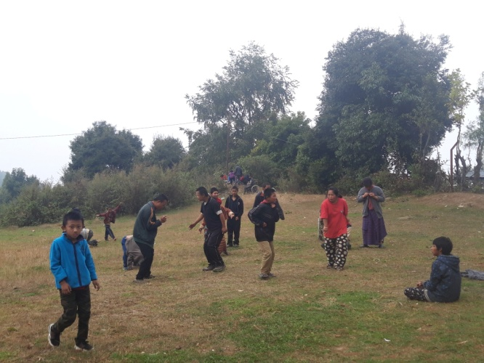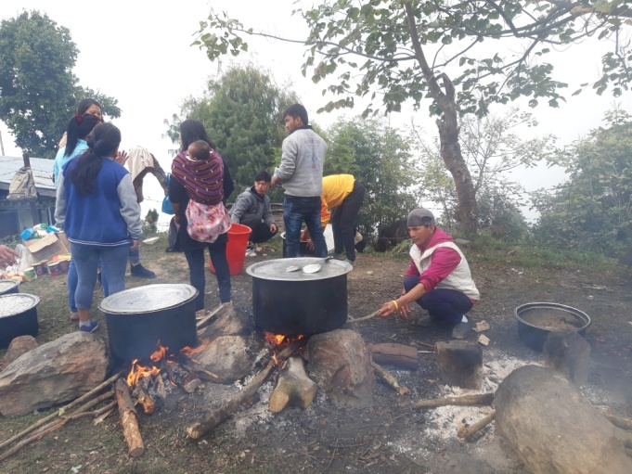

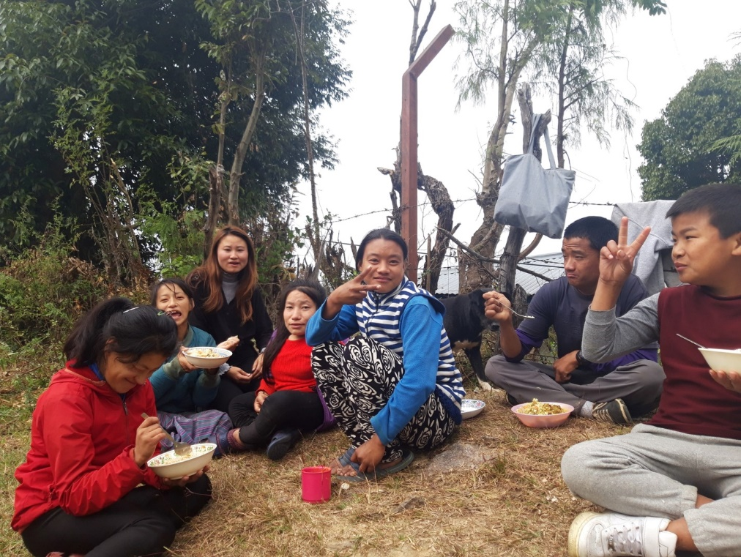
International Day of Persons with Disabilities
The United Nationals General Assembly 47/3 first proclaimed the annual observance of the International Day of Persons with Disabilities in 1992. This observance of the day was aimed at promoting understanding of issues related to disability and to mobilize the support for well-being, rights, and dignity of persons with disabilities. It also sought to raise awareness regarding the need for integration of persons with disabilities in every aspect of social, economic, cultural and political life.
On the 3rd December Draktsho observed the International Day of Persons with Disabilities by organizing its annual sports event in which the students participated in Olympic types of sports along with fun games. Similar event was also held at Draktsho East Centre in collaboration with Ability Bhutan Society (CBR team), Physio team from Trashigang Hospital, Khaling Lower Secondary school and Trashigang Middle Secondary School. The athletes took part in track and field games such as 100 mts race, long jump, shot put, wheelchair race, relay race and other fun games. This event is one of the highlights of the year as the day gives opportunity to raise awareness on people with disabilities, promoting their rights, mobilize support and equal participation for a happy and inclusive society.
The athletes were awarded certificates and prizes both in cash and kind with support from the Christmas Record Grant from Special Olympics International.
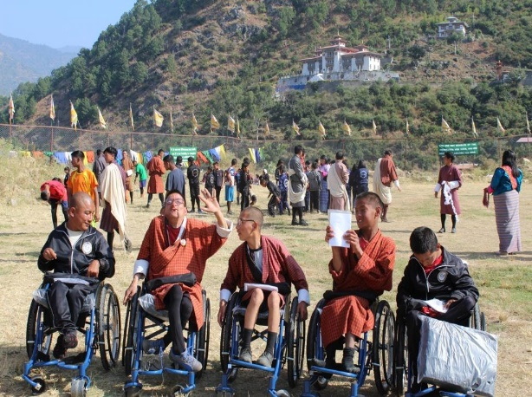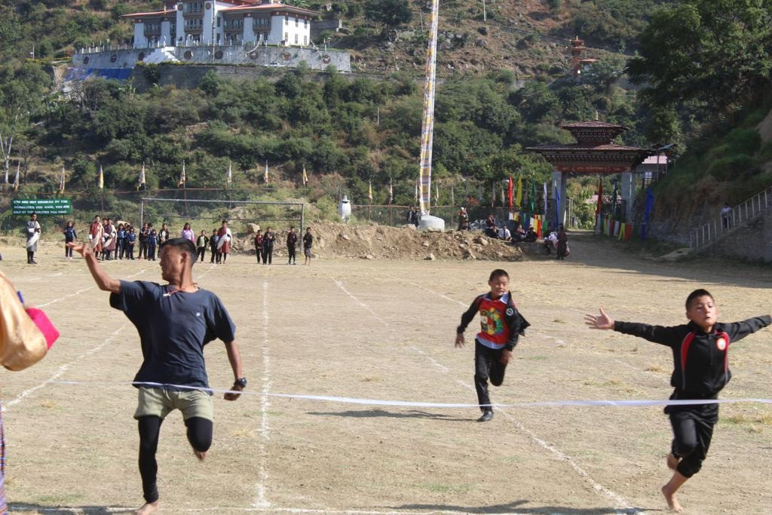
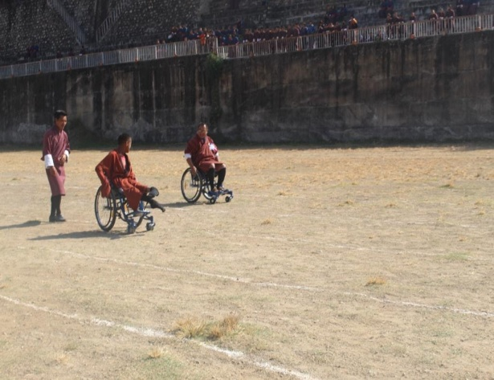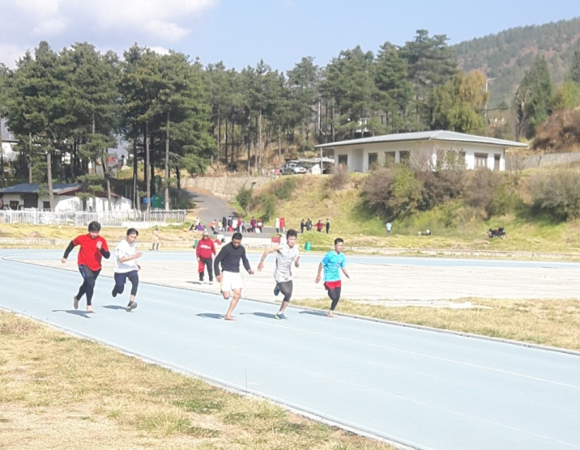
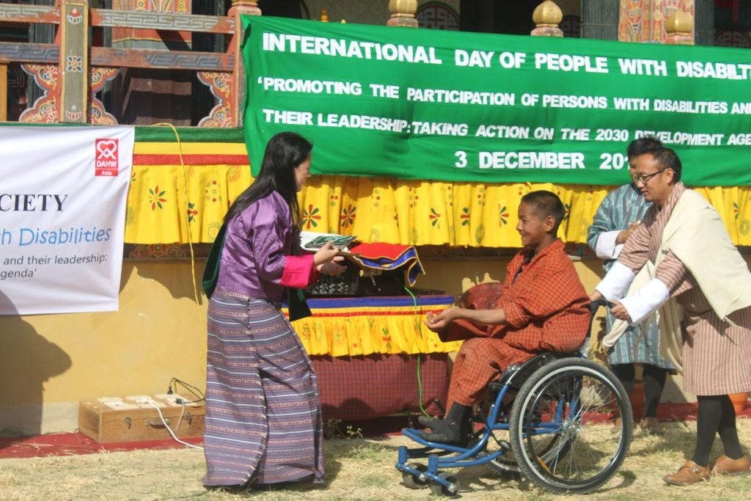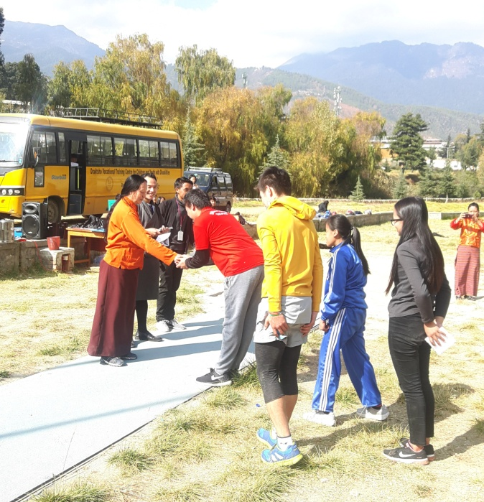

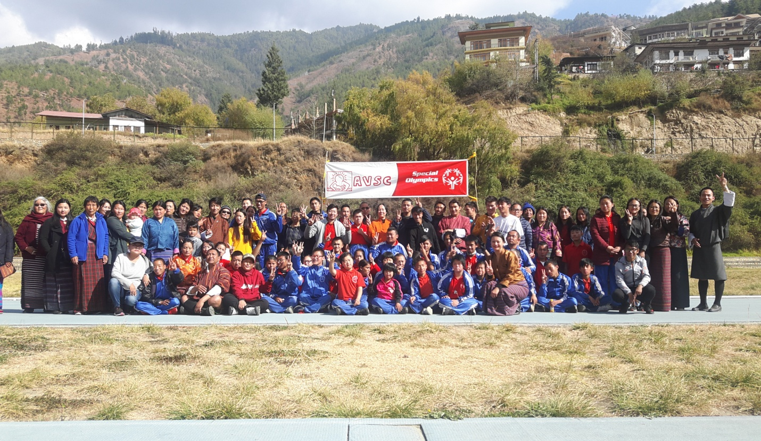

Programs and Activities
Vocational and Co-curricular programs:
The Vocational training and other co-curricular activities given below are some of the training programs offered at the centre. The vocational training is traditional based and which suits the capacities of the students. New skills depending on the requirement of the students are included annually.

Main Vocational Courses offered:
- Tailoring
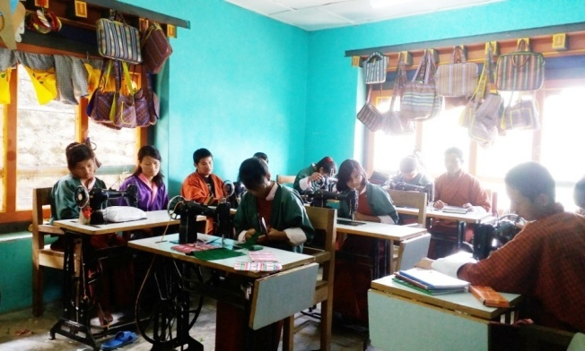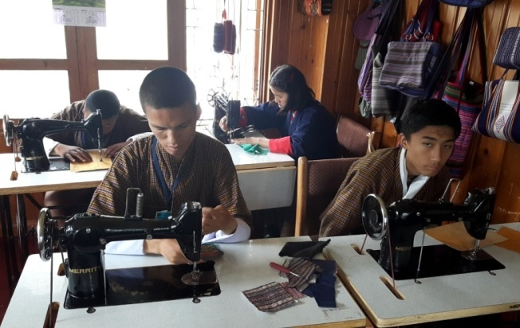
Tailoring course takes 2 to 4 years to graduate; an intellectually challenged may take more years.

- Traditional art and painting
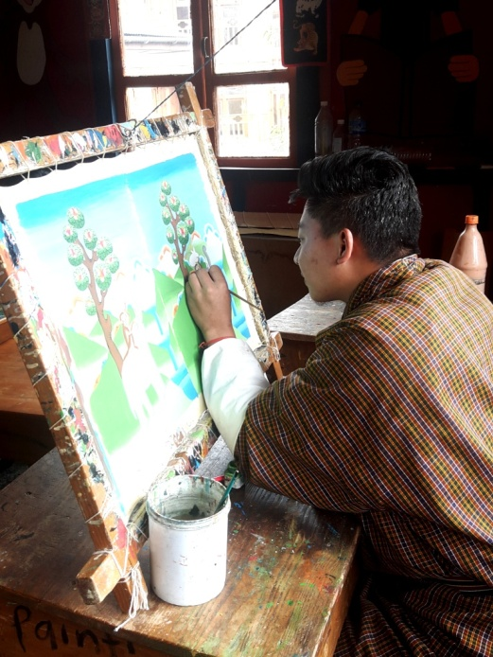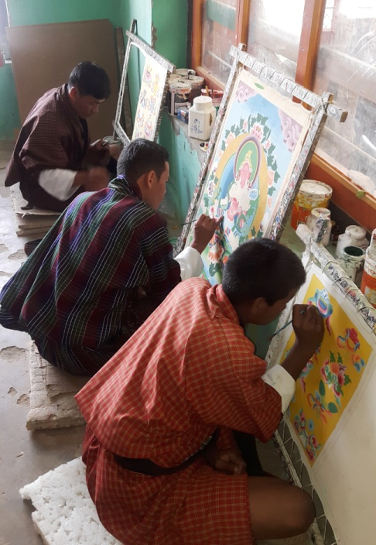
Art and painting takes 5 to 7 years to complete the course, however, it is flexible to allow the students learn at ease.

- Embroidery
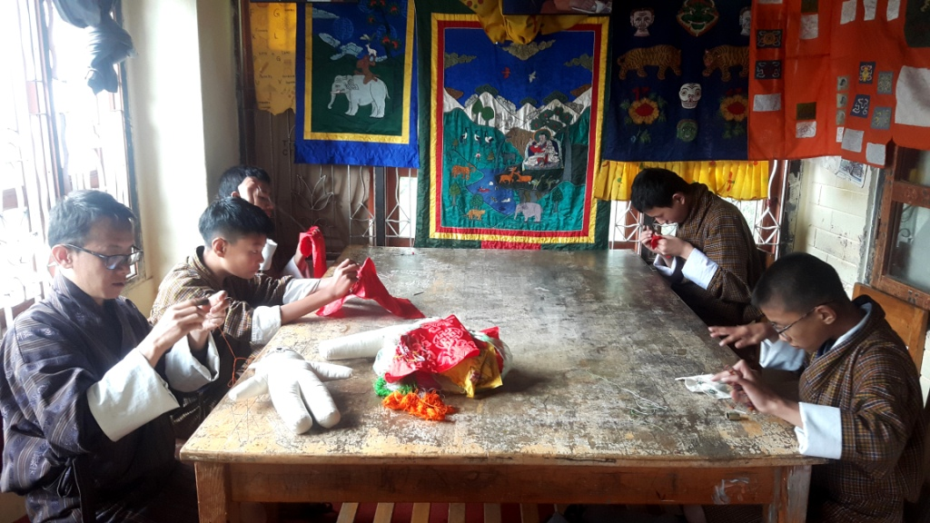
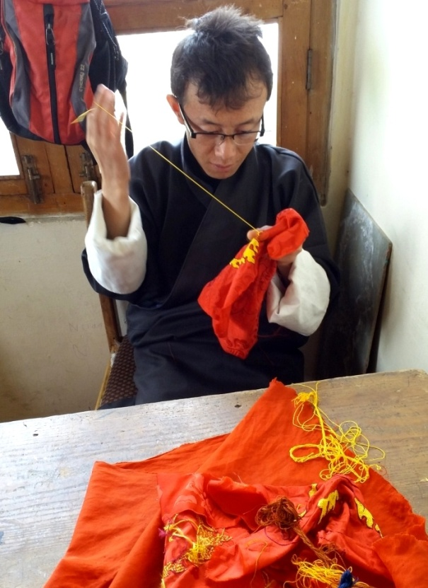
Embroidery is a high level training, it needs good hand eye coordination and good concentration. Most of the students in this class are with hearing and speaking impairment, there are few students with mild intellectual challenges. The course takes 5 to 7 years to graduate.

- Weaving
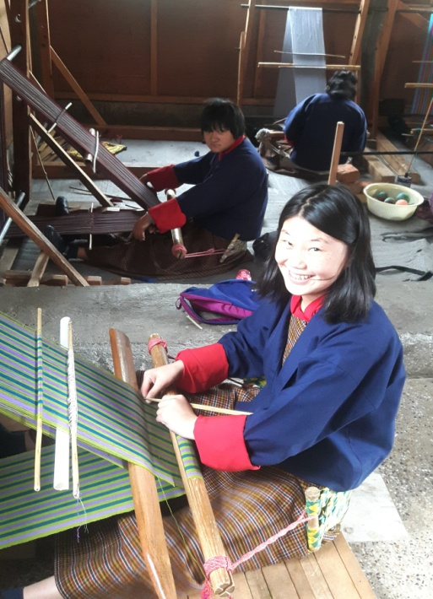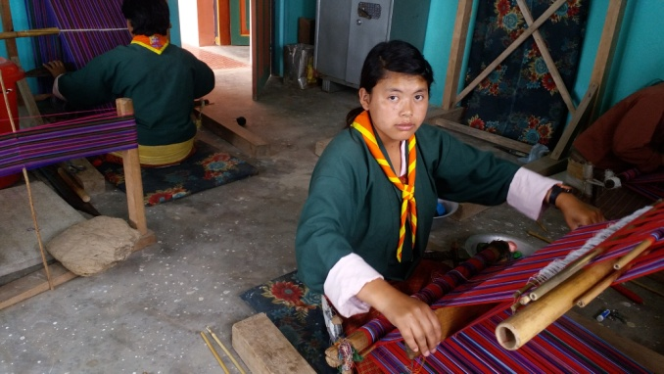
Weaving is an interesting skill development course. There are all types of youth learning weaving as it has several areas of practice. Though it is more suitable for women, men also enjoy weaving. The course takes 3 to 7 years, depending on the level of intelligence and hand coordination skills.

- Basket weaving(cane and plastic)
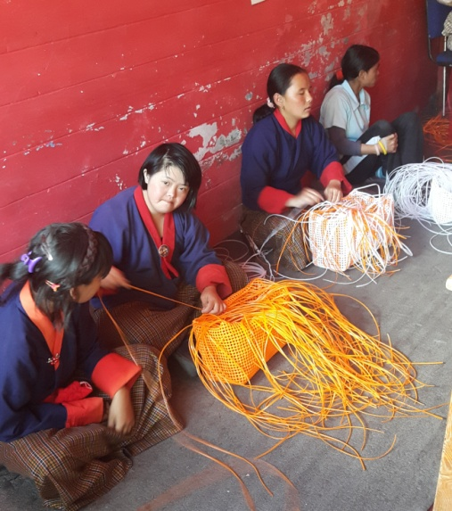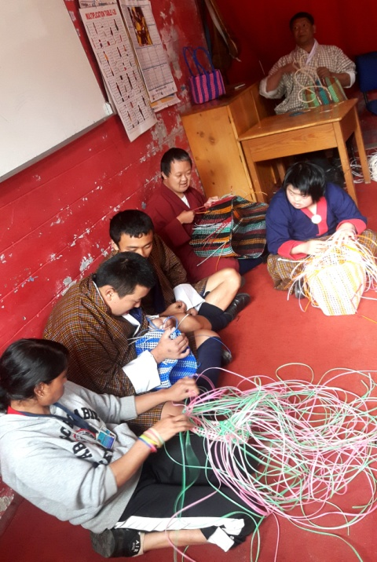
Basket weaving is pre-vocational program for Draktsho. Most of the intellectual students are placed here to determine their motor skills before transferring them to higher level training. Basket weaving develops hand eye coordination, able to sit for a long time in their seats, it also helps control behaviour problem and learn discipline.

- Souvenir carpentry (wood carving)
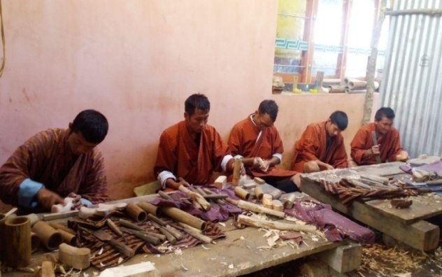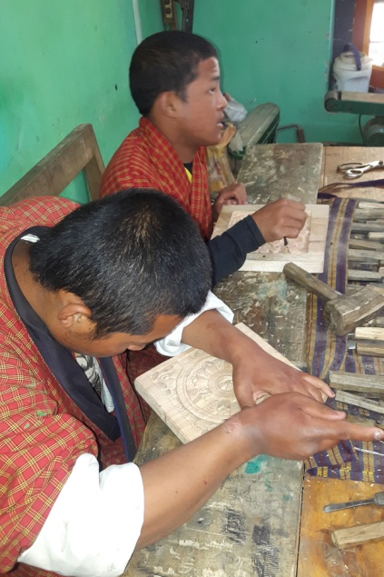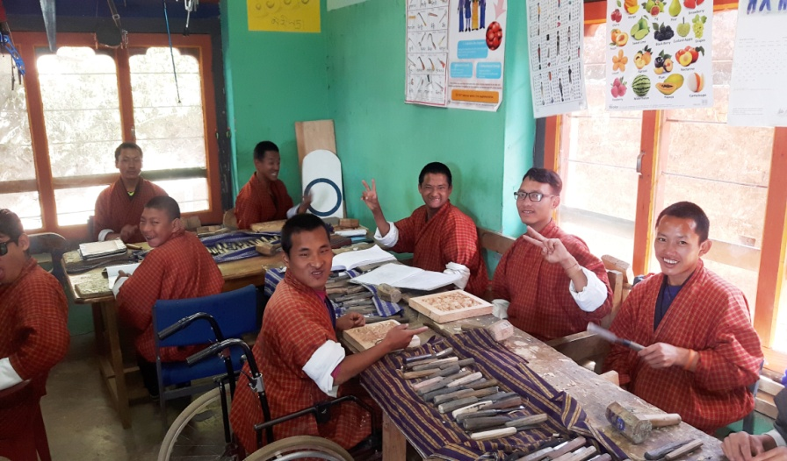
Wood carving require good hand eye coordination, besides learning carving and designing, we make small wooden souvenirs. The period of training is 5-7 years.

- Souvenir making(cards, bookmarks and doll making)
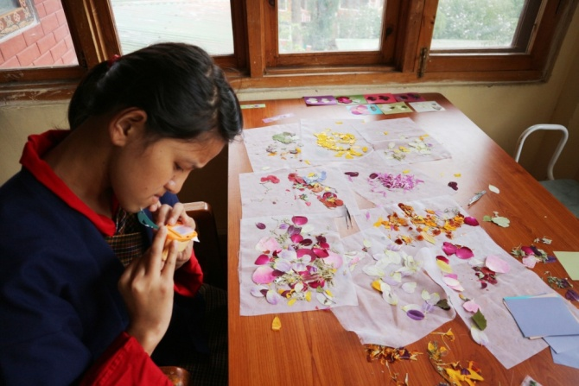
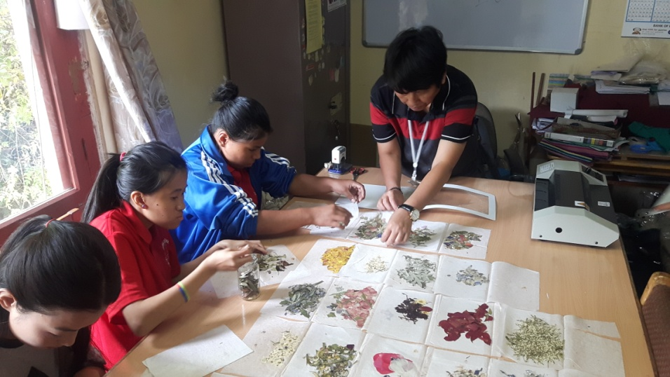
Book marks, Cards, Paper bags and boxes, small dolls are made by youth with mild cerebral palsy students. The training in this area determines the creativity of a student as they design the cards and book marks. It takes 1 to 3 years of training depending upon their individual capacity.

- T-Shirt and Mug Printing
The printing training need youth with high level intelligence. We have very few students in this class.

- Envelope Making
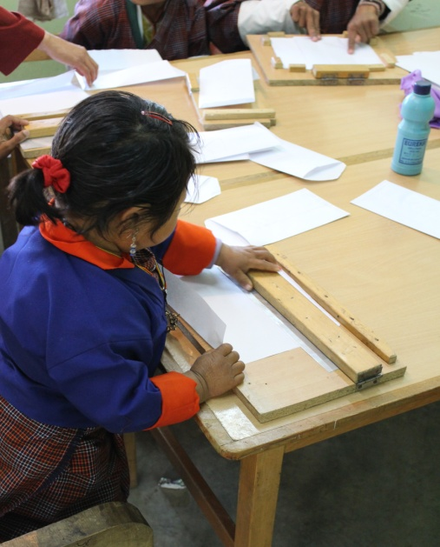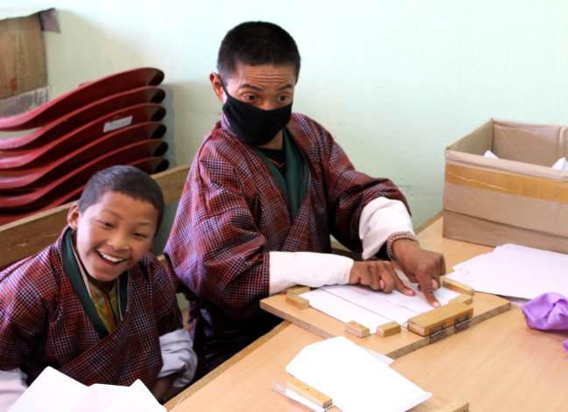
Envelopes are made by youth with moderate IQ level students and physically challenged students. It takes a group of students to complete an envelope as they lack fine motor skills.

- Pottery
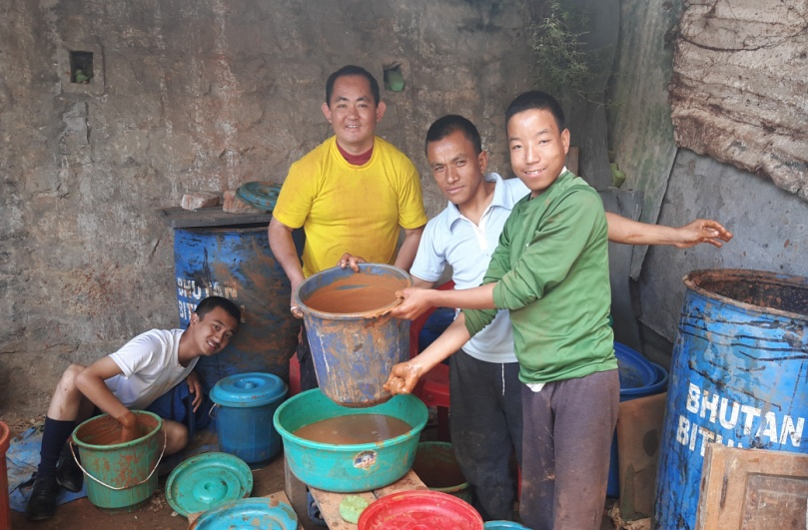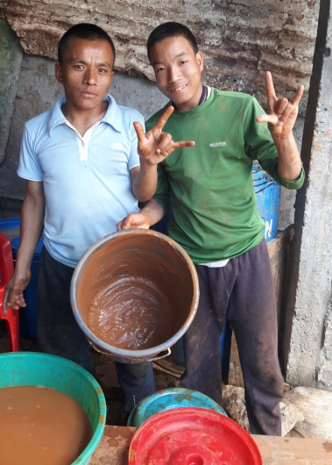
Pottery is a new skill initiated to train severely challenged students. The outcome of this training is yet to determine.

11. Doll Making Unit

The Doll Making Unit was initiated with support from Save the Children Bhutan with the sole purpose of engaging those students who cannot progress with other vocational trades. The doll making unit started by making traditional mini dolls and then progrsssed forward to make the "Four Friends" thuenpa puengzi. Draktsho started this new project so that these students could be happily engaged in something productive. There are 6 students in this unit who produce these soft cute teddy bears that are supplied to DUSIT D2 Hotel in Thimphu. This is the first of its kind production in Bhutan made by youth with disabilities.

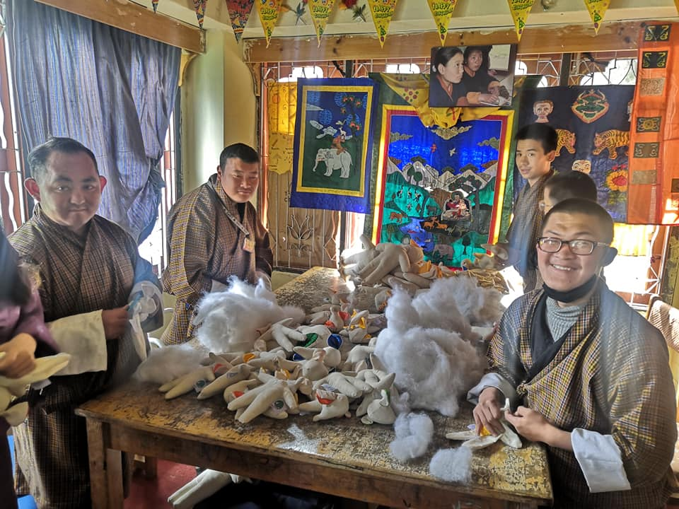
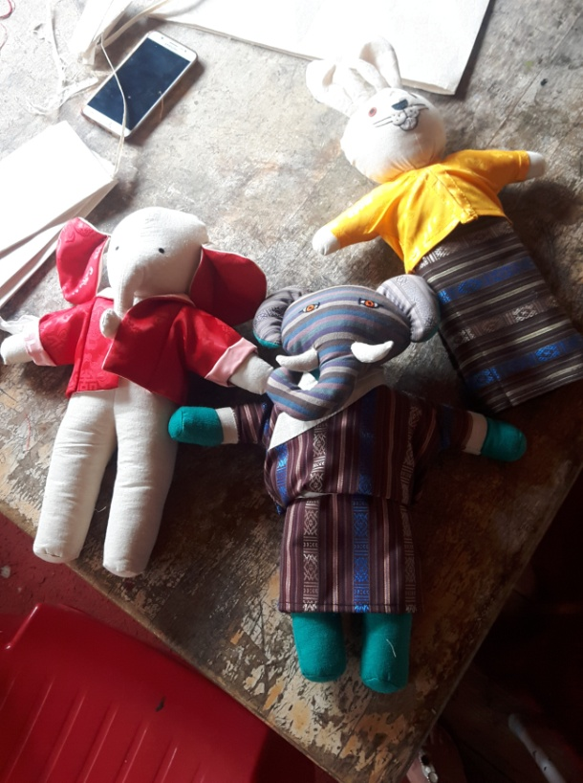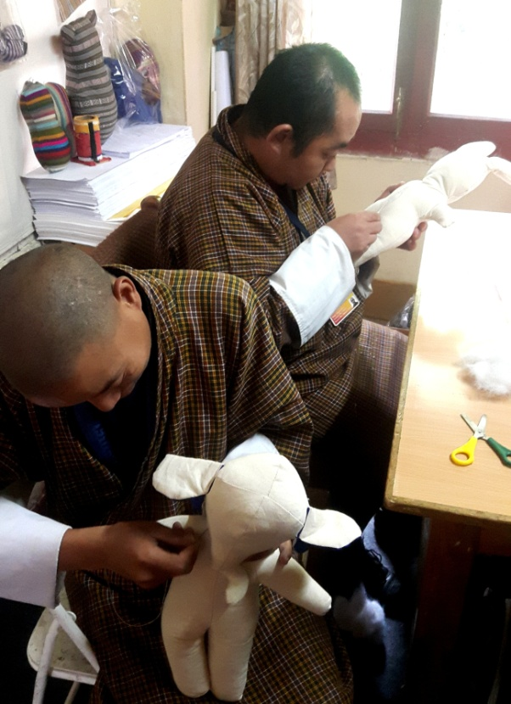

12. Special Education:

Special Education has always been one of the core activities of Draktsho since the beginning. The students are taught 3 subjects, English ,Maths and Dzongkha for 1and half hours every day and this is mandatory for all students. There are young children aged between 7-17 years who need Special Education and other life skills training on daily basis. Apart from basic academics the students in this unit are taught the activities of daily living(ADL) skills, social skills, singing, drawing and music to improve their behavioural and social skills.

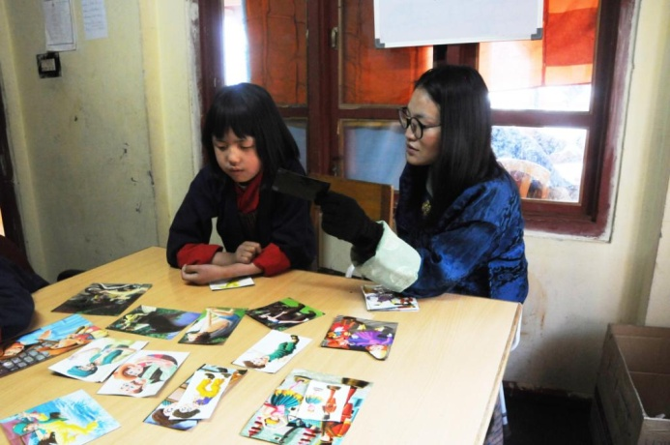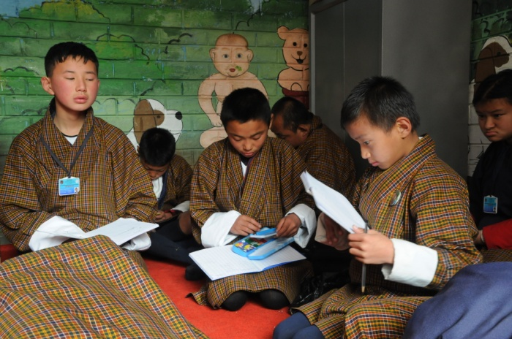

Life skills offered:
- Personal management skills
- Sign language(communication skills)
- Social Behaviour, domestic behaviour
- Work related or Functional Academic
- Safety skills
- Occupational skill and basic education(Special education)
- Vegetable and Flower Gardening
- Sign Language

Co-curricular Activities:

- Social skills: dancing, singing, acting and cultural disciplinary programs are taught to the students to built their communication and socialization skills. These activities not only boost's their self esteem but also make them happy and feel inclusive.

- Physical fitness programs: Draktsho is often used as the base for promoting sports for athletes with disabilities as Draktsho has maximum number of children and youth with various types of disabilities. Draktsho organizes a sports competition annually nationwide to promote the Special Olympics movement giving all special athletes a platform to showcase their abilities. This activity not only keeps one fit but brings together everyone experiencing joy, happiness, contentment and victory through inclusion.
The Special Olympics Bhutan which was founded in 2010 by people from different walks of life also operates under the umbrella of Draktsho.
In 2011, 4 athletes (2 boys and 2 girls) participated at the Special Olympics held in Athens, Greece where they participated in track and field events. The athletes won gold in the mixed relay race for the first time. Again in 2015 4 athletes with intellectual disabilities participated at the Special Olympics held in Los Angeles, California. The team brought home 6 medals (3 gold's,2 bronzes and 1 silver) in individual events. They created history in Bhutan by winning that many medals at an Olympic level. They broke barriers proving many wrong and becoming the pride of the nation.
- Apart from the vocational training, educational and life skill program, the students are also given opportunities to development individually through counseling, personal coaching and guidance.

Following one of its long term goals Draktsho has successfully established its first branch in Kanglung,Tashigang. The centre is known as Draktsho East Centre and unlike the centre based in Thimphu it provides boarding facilities to 130 students. The students at Draktsho Thimphu are day scholars and at present there are 210 students (137 boys and 73 girls) in total.

We continue to reach out to the needy and are always looking for avenues to cater our services for all.

Success Stories
- The construction of Learning and Library Block was completed with support from Opening Your Heart to Bhutan. The principal's office, staff meeting/conference room,1 library room and 2 guest rooms are located in this block.

- 3 athletes from Draktsho won 2 gold medals, 1 silver and 1 bronze. The details of the winners are as follows:
- Pelden: 1 gold medl ain 200mts race and 1 bonze in shot-put
- leki Lhaden: 1 gol dmedal in 100 mts race
- Chencho Dorji: 1 Silver in 100 mtrs race

Challenges
- Overhead and maintenance cost has always been the biggest challenge for Draktsho.
- No infrastructure for Draktsho Thimphu Centre. At present Draktsho is located in a rented building and wishes to build its own infrastructure.

Thank You,

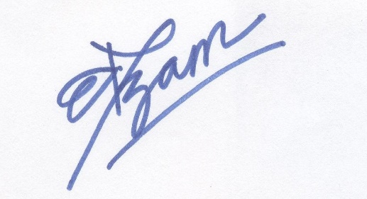

Deki Zam,
Executive Director
Draktsho
Email. dekzang@hotmail.com
Mob: 77273144

